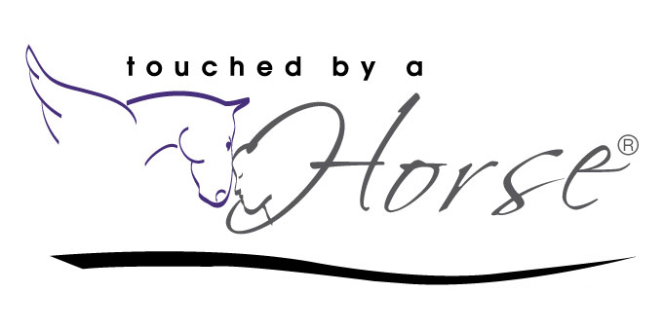
Touched by a Horse Certification Program Application
Each person has their strengths and weaknesses. This application will give us an idea of where you feel you are at the start of the program. Prior experience is not required – we look forward to working with all levels of students and providing them with the tools they need to be successful. Please describe any experience you might have with horses, coaching/therapy, somatics and/or business. We will be in touch once we have had the opportunity to process and review your application.
PERSONAL INFORMATION
First Name: ________________________________________________ Last Name: _________________________________________________ Date of Application: __________________________________________ Email Address: ______________________________________________ Phone Number: _____________________________________________ Street Address: _____________________________________________ City, State, Zip Code: _________________________________________
Country: ___________________________________________________ Time Zone: _________________________________________________
EXPERIENCE AND EDUCATION
Highest Level of Education: ____________________________________ Degree (if any): _____________________________________________ School(s) Attended: __________________________________________ __________________________________________________________
Have you completed any certifications, skills, training, or workshops other than with horses that you feel are applicable to this program? If so, please describe: ________________________________________
__________________________________________________________ __________________________________________________________ Have you ever facilitated OR led a group process? _________________ Co-facilitated? ______________________________________________ Are you a licensed therapist? (No prior experience required)
__________________________________
If yes, what type of practice? __________________________________

Have you ever worked with a professional coach? _________________

Are you already a coach? _____________________________________

If so, please tell us about your experience: _______________________ __________________________________________________________ __________________________________________________________ If yes, what type and where did you train? _______________________ __________________________________________________________ Have you ever owned your own business: _______________________ If so, please tell us about your experience: _______________________ __________________________________________________________ __________________________________________________________ Do you have any training or experience in Somatics? _______________ If yes, please explain: ________________________________________ __________________________________________________________ What does it mean to you to “partner” with horses? _______________ __________________________________________________________ __________________________________________________________
Do you have any prior experience with horses? ____________________ If so, what kind of horsemanship skills do you have? ________________ __________________________________________________________ __________________________________________________________
Do you own your own horse or horses? (Owning your own horse is not required before, during or after the program) _____________________
What is it about the Equine Gestalt Coaching Method (EGCM) that inspires you to apply and participate in this 2 - year certification program? __________________________________________________
__________________________________________________________ __________________________________________________________ __________________________________________________________
Is there anything else you would like for us to know about you that would assist us in determining your acceptance to Touched by a Horse?
__________________________________________________________ __________________________________________________________ __________________________________________________________ __________________________________________________________

How did you hear about Touched by a Horse? If you were referred by someone we kindly ask that you share their name with us so we can offer our gratitude! __________________________________________
__________________________________________________________

